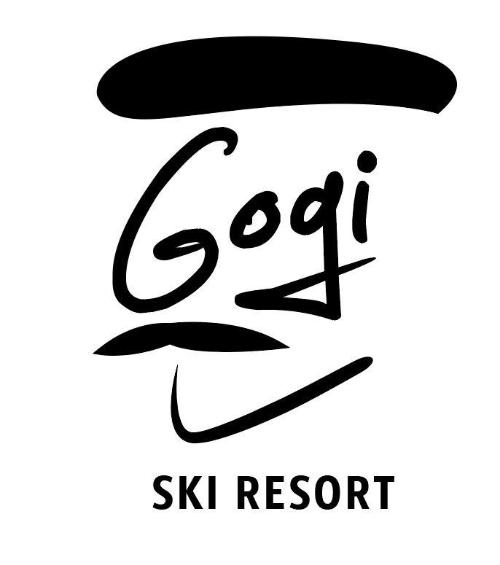

Dear Guests,

First of all have an incredible stay and enjoy every day of your stay.

Here we have some information and hotel rules which is very important to know:

*WiFi: Gogi Password: weloveyou
*Breakfast time: 08:30 to 10:00
*Dinner time: 17:00 to 18:30
*Check out time 11am
*You can drink tab water
*Please don’t eat in Rooms (We have cozy restaurant area and you can come and sit there any time from 8am to 11pm)
*Don’t smoke in rooms, It is prohibited by Georgian law and we have smoking fine - 300Gel (For this we have balconies
*Dear Guest, every day millions of gallons of water are used to wash towels that have only been used once. Please if you want to change your towel tell us and we will do that.
*We want you to know that we clean rooms when you ask, you have signs in rooms or come to reception and we will do it.
*We have fantastic ski storage which heats and dries the skis, you can change your boots, leave equipment there, take your slipper and relax and we will keep everything safe and dry for next day :)
*Ski Room code from outside is: 2580#
*In every room there is small carpets, you can take them and put your shoes on.
*In case any questions please don’t hesitate to ask, our whats app: +995 591 17 48 37

Enjoy your stay and have a wonderful time
Ski Resort team


